Introduction to San Diego Field Worksheet (SD Field Worksheet):

The SD Field Worksheet provides the CSW with quick access to client case information. When you receive a new case you can search through CSW/CMS for this information. Many CSWs then use this information to create a Face Sheet for each case. This is a time consuming process but it is very beneficial to the CSW and to colleagues. The SD Field Worksheet takes all the labor out of creating a Face Sheet for your cases.

Objective:

Create a single document that has the contact information and vital case information.

The SD Field Worksheet includes:
- Case Name and State ID #
- Name, Birthdate, Age, Gender, Address, Phone Number, Ethnicity, Language, ICWA and Tribal Affiliation
  - Parents
  - Children
- Children Information
  - School information (Including address and phone number)
  - Doctors information (Including name, phone and last seen)
  - Also includes: Birthplace, Social Security Number and Court Number
- Parent Information
  - Child relation
  - Employer Information
  - Maiden and AKA names
  - Drivers License
  - Military Service
- Contact information for relatives
- Contact information for caregivers
- Contact information for collaterals
- Contact information for Minor’s Attorneys



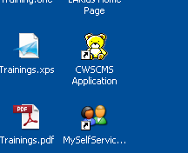
First Time Log-In Process

Step 1

Access CWS/CMS by clicking on
the shortcut from your Desktop

Note:
Login –

NOTE: You should have already created a Password to
Log into CWS/CMS and there is no need to create a new one

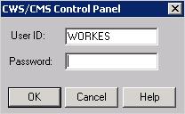
Username: First 5 letters of your last name
followed by the first letter of your first name
e.g.: Social Worker = WORKES
Password: Eight characters with a number and
CAPITAL letter (for extra strength add a punctuation)
e.g. G00D2GO!

If you need your password reset, contact the COA in your office.

Step 2

Enter your USERNAME and PASSWORD.
Then Click “OK”

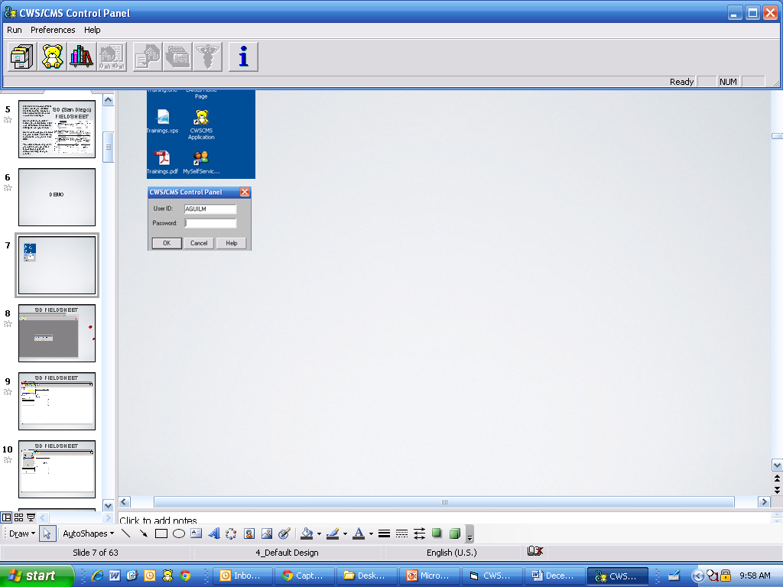
Step 3

Click on the “Client Services Application”

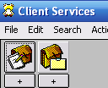
Step 4

Then Click on the “Case Folder”

Step 5

Next Click on the Child in the case that you want to generate the SD Field Worksheet.
Then Click “OK”

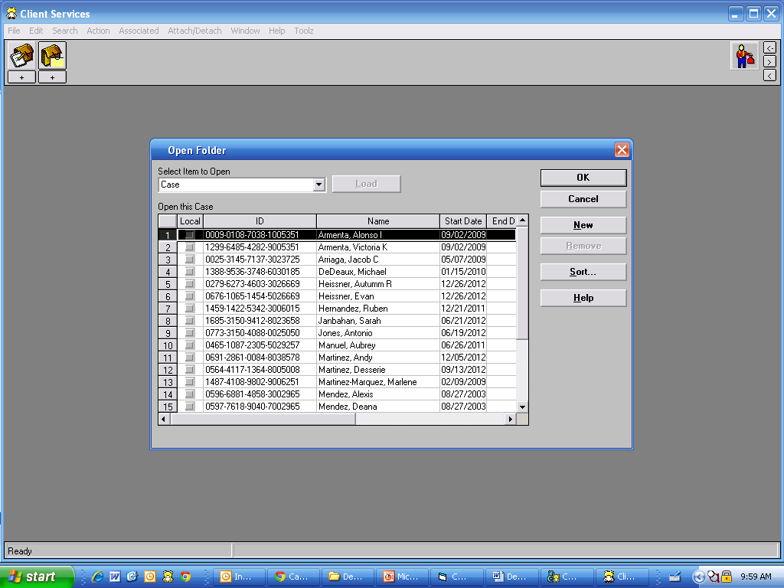

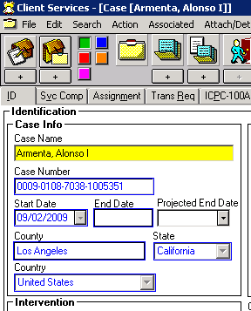  Step 6  Once the Client Services Dialog box opens  Click “Yes”  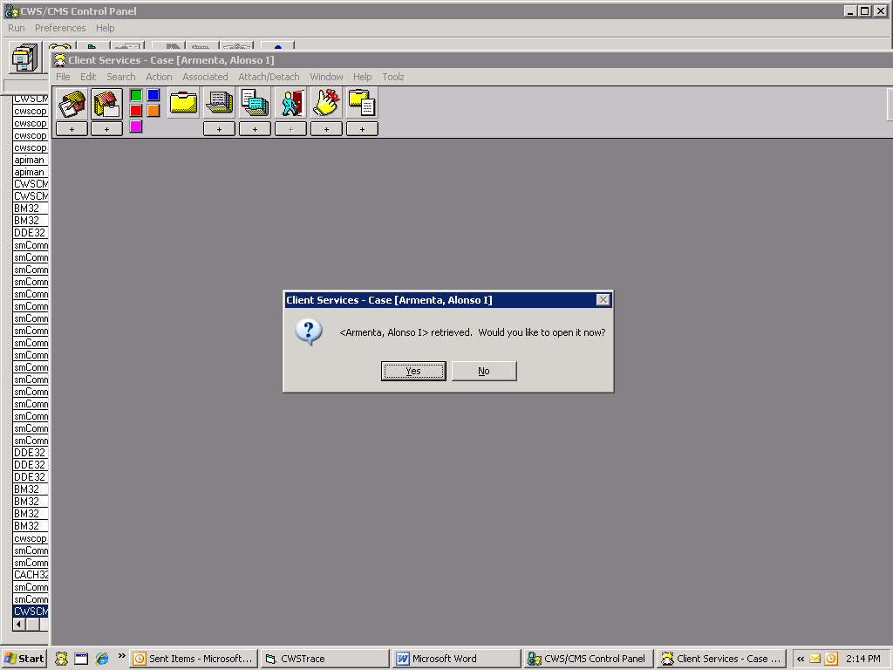 |  | Step 7  Once the Case opens up, click on “File”
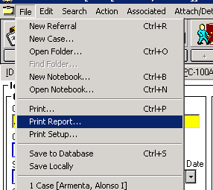  Step 8  Double Click on “Print Report” | Step 9  Click on Drop Down arrow  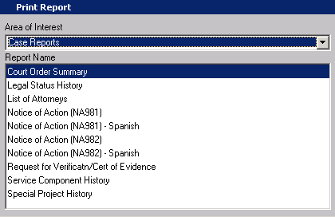
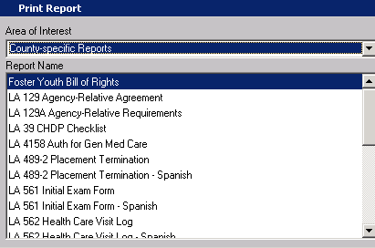  Step 10  Click on “County Specific Reports”  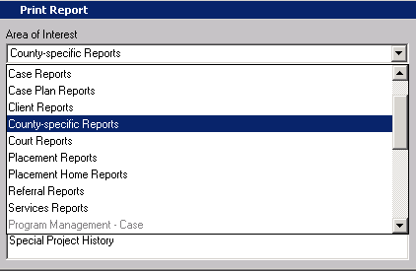 | Step 11  Click and Hold the Scroll Bar and drag it all the way to the bottom of the menu.

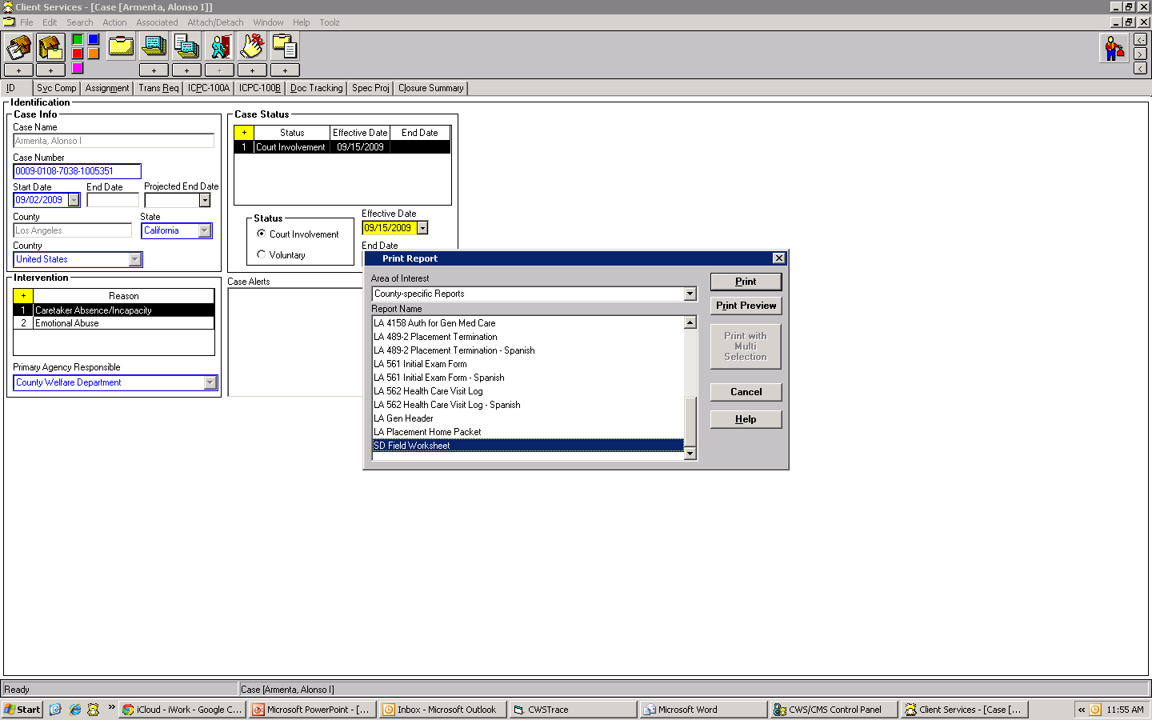
Step 12

Click on “SD Field Worksheet” option from
the Drop Down menu

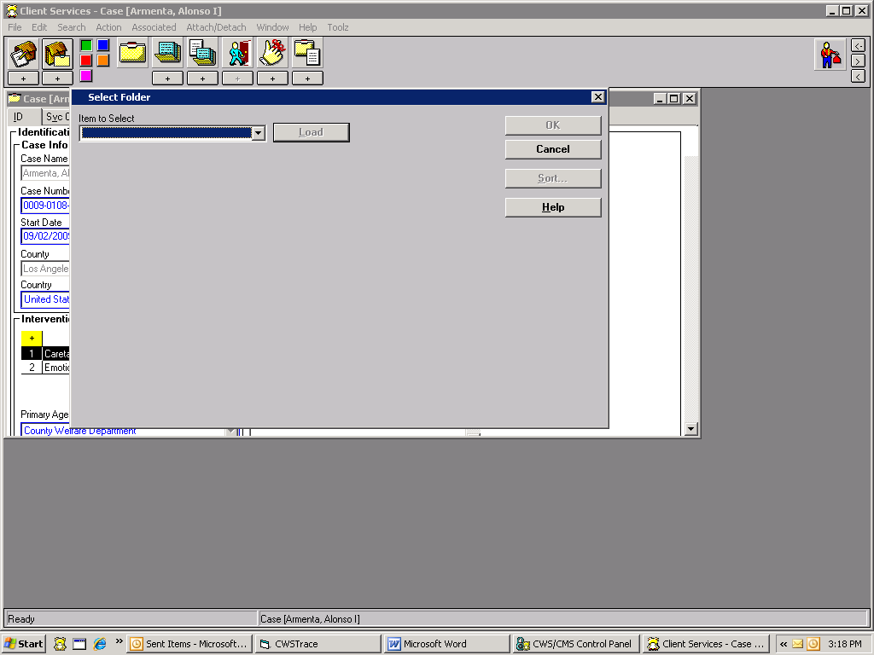  Step 13  Click “Print” | Step 14  Click on Drop Down arrow

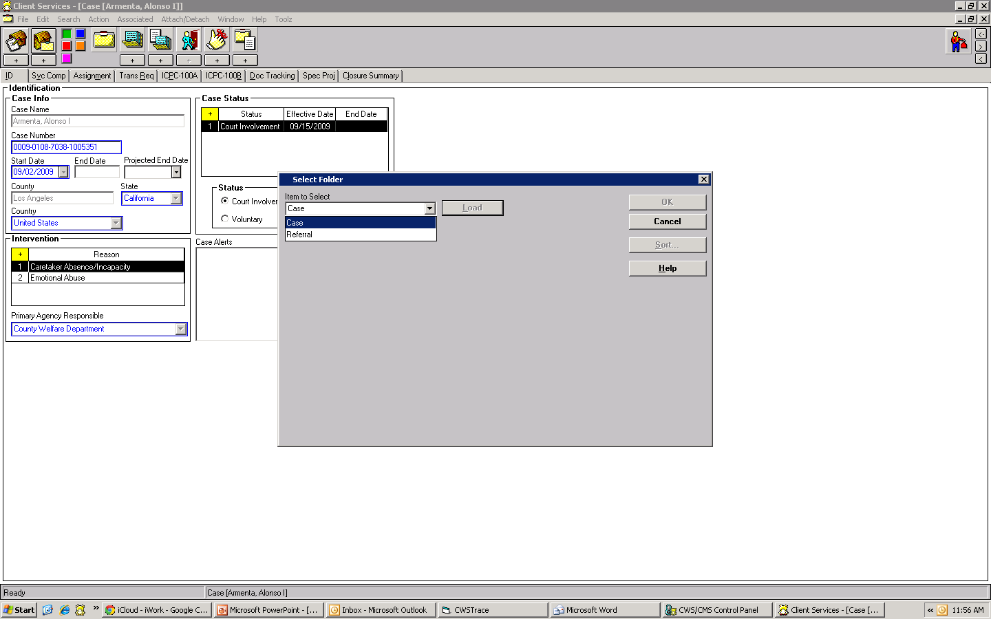  Step 15  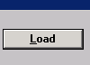  Select “Case” from the Drop Down Menu | Step 16  Click “Load”

Step 17

Double Click on the Case

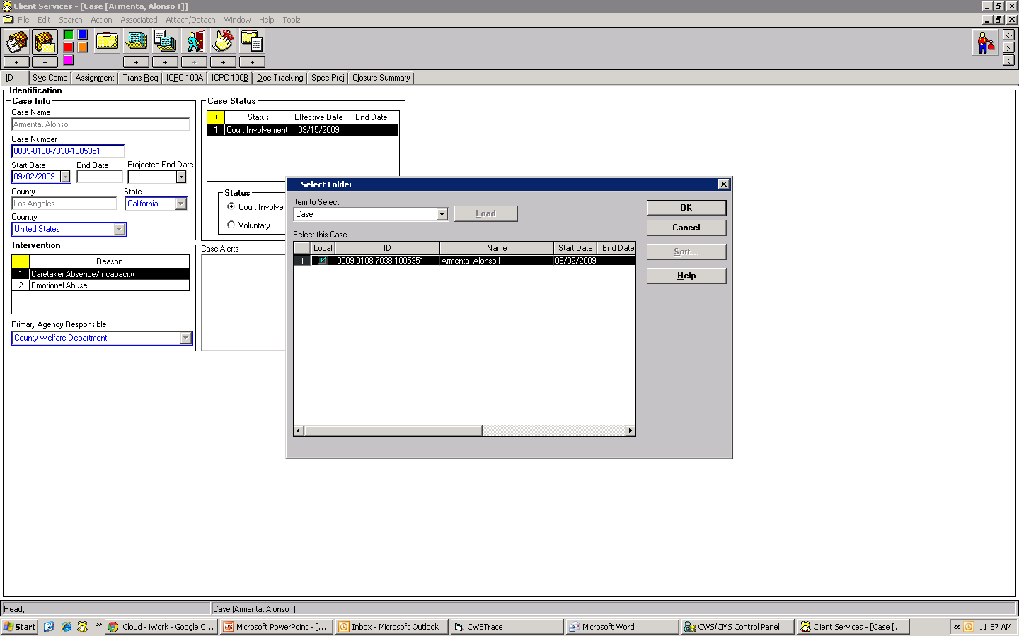

After you Double Click on the case, the SD Field Worksheet will automatically generate.
Congratulations! You have successfully competed generating the SD Field Worksheet!

